Llandow Ward Community Council Report
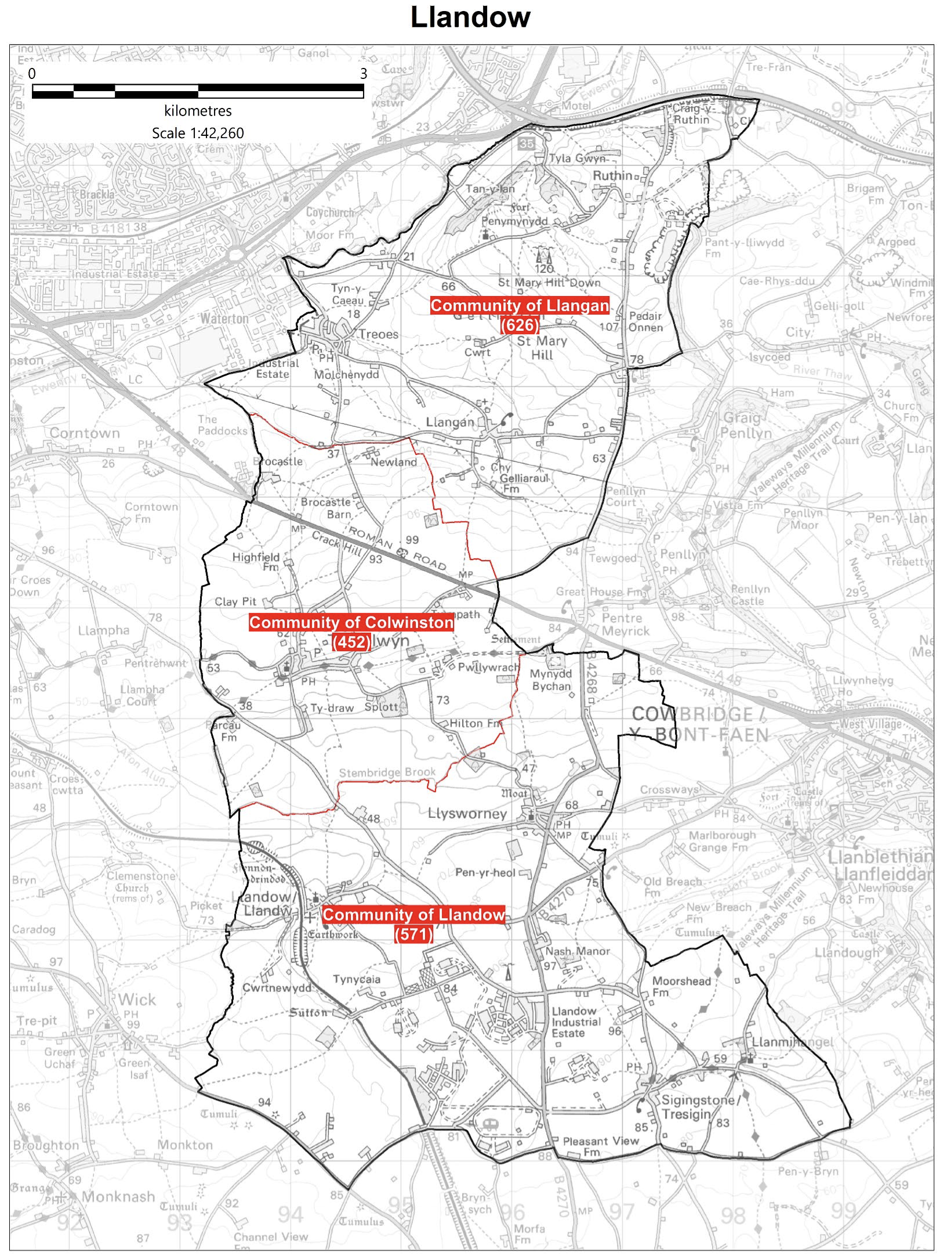

Cllr. Christine Cave email: cacave@valeofglamorgan.gov.uk
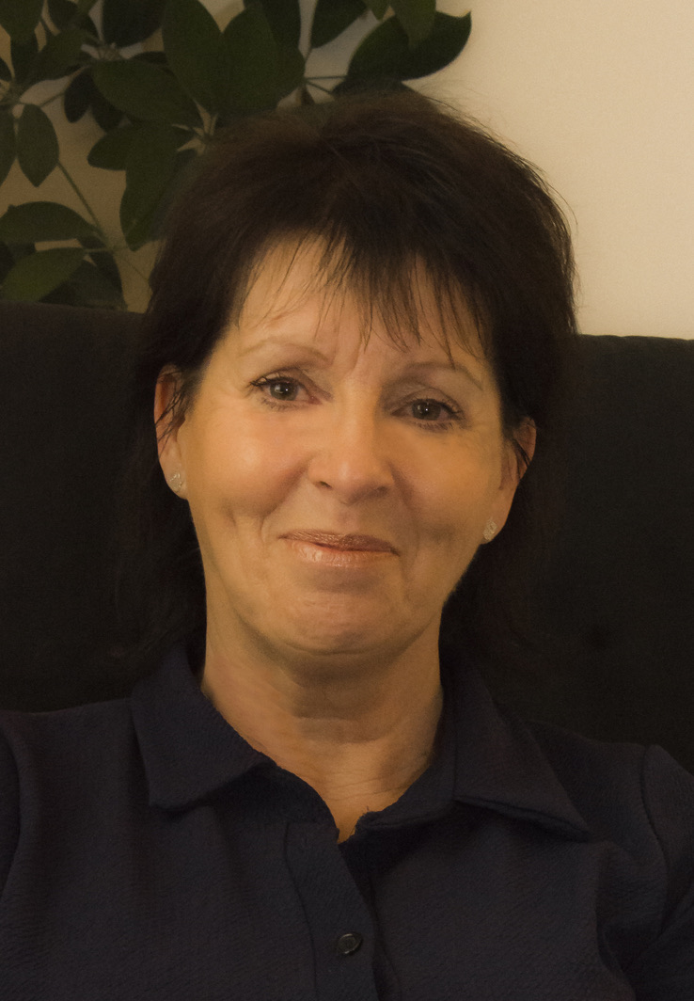
Date: March/April 2023- Report to the Community Councils (CC) in the Llandow Ward: Colwinston; Llandow/, Llysworney, Sigingstone, Sutton and Llangan/Treoes and St Mary Hill.

Vale of Glamorgan Full Council meeting date for 2022/23

24th April, 2023

Members of the Cabinet:
Councillor L. Burnett (Executive Leader and Cabinet Member for Performance and Resources) – Labour Party
Councillor B.E. Brooks (Deputy Leader and Cabinet Member for Sustainable Places) – Labour Party
Councillor R.M. Birch (Cabinet Member for Education, Arts and the Welsh Language) – Labour Party
Councillor M.R. Wilson (Cabinet Member for Neighbourhood and Building Services) Labour Party
Councillor M.R. Wilkinson (Cabinet Member for Public Sector Housing and Tenant Engagement) Labour Party
Councillor E. Williams (Cabinet Member for Social Care and Health) Llantwit First Party
Councillor S. Sivagnanam (Cabinet Member for Community Engagement, Equalities and Regulatory Services) Labour Party
Councillor G. John (Cabinet Member for Leisure, Sport and Well-being) Llantwit First Party

Full Council Meeting
MONDAY, 6TH MARCH, 2023 AT 6.05 P.M.
REMOTE MEETING
Agenda PART 1
1. Apologies for absence.
[View Minute]
2. (a) To hear the roll call of Members (b) To receive declarations of interest under the Council’s Code of Conduct.
(Note: Members seeking advice on this item are asked to contact the Monitoring Officer at least 48 hours before the meeting.)
[View Minute]
3. To approve the minutes of the meetings held on:
(a) 5th December, 2022;
(b) Special Meeting, 11th January, 2023;
(c) Special Meeting, 30th January, 2023.
[View Minute]
4. To receive any announcements from the Mayor, Leader, Members of the Cabinet and the Chief Executive and to receive any petitions submitted by Members.
[View Minute]
Reference –
5. Cardiff Capital Region City Deal – Joint Scrutiny Committee Nominated Deputy – Environment and Regeneration Scrutiny Committee: 13th December, 2022.
[View Minute]
Report of the Chief Executive –
6. Use of the Chief Executive’s Emergency Powers.
[View Minute]
Reports of the Monitoring Officer / Head of Legal and Democratic Services –
7. Consultation with Non-Domestic Rate Payers.
[View Minute]
8. Amendments to the Council’s Constitution.
[View Minute]
9. To consider the following proposal(s) from the Executive in relation to the Council’s Policy Framework and Budget
Item | Date of Meeting | Minute No.
(a) Housing Revenue Account Business Plan 2023/53 (2)  [View Minute] | 2nd February, 2023 | C215
(b) Council Tax Unoccupied Dwellings: 2023/24 (1-4)  [View Minute] | 16th February, 2023 | C224
(c) Draft Vale of Glamorgan Council Annual Delivery Plan 2023-24 (3)  [View Minute] | 16th February, 2023 | C226
(d) Capital Strategy 2023/24 and Final Capital Programme Proposals 2023/24 to 2027/28 (1-8) (View Reference)  [View Minute] | 27th February, 2023 | C236
(e) Treasury Management and Investment Strategy 2023/24 and Update 2022/23 (2 and 3) (View Reference)  [View Minute] | 27th February, 2023 | C237
(f) Final Budget 2023/24 and Medium Term Financial Plan (MTFP) 2023/24 to 2028/29 (2 and 3) (View Reference) [View Supplementary Information]  [View Minute] | 27th February, 2023 | C238
(g) Pay Policy 2023/2024 (2)  [View Minute] | 2nd February, 2023 | C213
(h) Chief Officer Appraisal Scheme – Proposed Modifications (2)  [View Minute] | 16th February, 2023 | C223

10. To set the Council Tax 2023/24. [View Revised Council Tax information]
[View Minute]
11. To inform the Council of the Use of the Urgent Decision Procedure under Article 15.14 of the Constitution.
Item | Date of Meeting | Minute No.
(a) Council Tax Unoccupied Dwellings: 2023/24 (2)  [View Minute] | 1st December, 2022 | C158
(b) Council Tax Base: 2023/24 (2)  [View Minute] | 15th December, 2022 | C168
(c) Final Housing Revenue Account (HRA) Budget Proposals 2023/24 and Rent Setting 2023/2024 (5)  [View Minute] | 5th January, 2023 | C176
(d) Proposal to Transfer Specialist Resource Base at Llandough Primary to Ysgol y Ddraig (3) | 5th January, 2023 | C177
(e) Budget 2023/24 for Consultation and Further MTFP Update (6)  [View Minute] | 19th January, 2023 | C189
(f) Draft Transgender Inclusion Toolkit and Guidance Document for Schools and Other Settings (5)  [View Minute] | 19th January, 2023 | C193
(g) The Council’s Response to the Welsh Government Consultation: Electoral Administration and Reform White Paper (2)  [View Minute] | 19th January, 2023 | C200
(h) Draft Vale of Glamorgan Council Annual Delivery Plan 2023-24 (4)  [View Minute] | 16th February, 2023 | C226

12. To receive questions and answers pursuant to Section 4.19.2 – 4.19.7 of the Council’s Constitution (i.e. questions on any matter in relation to which the Council has powers or duties or which affects the Vale of Glamorgan).
[View Minute]
13. Questions from the public.
19 questions have been received.
[View Minute]

CABINET MEETINGS IN MARCH 16th and 30th March

Cabinet meeting Minutes of a hybrid meeting held on: 2023 all remote meetings

THURSDAY, 30TH MARCH, 2023 AT 11.00 AM
AGENDA
1. Apologies for absence.
[View Minute]
2. Minutes of the Meeting held on 16th March, 2023.
[View Minute]
3. To receive declarations of interest and the nature of such interests under the Council’s Code of Conduct.
(Note: Members seeking advice on this item are asked to contact the Monitoring Officer or Democratic Services at least 48 hours before the meeting).
[View Minute]
Reference –
4. The Vale of Glamorgan Council’s Community Boundary Area Review – Community Liaison Committee, 23rd March, 2023. (View Reference)
[View Minute]
Report of Meeting –
5. Cardiff Capital Region Regional Cabinet Meeting – 30th January, 2023.
[View Minute]
Report of the Executive Leader and Cabinet Member for Performance and Resources –
6. Service Level Activities and Performance Targets to Deliver the Vale of Glamorgan Council's Annual Delivery Plan 2023/2024.
[View Minute]
Reports of the Deputy Leader and Cabinet Member for Sustainable Places –
7. ECO4 Flex Joint Statement of Intent and Memorandum of Understanding.
[View Minute]
8. Funding and Delivery of the Greenlinks Community Transport Service.
[View Minute]
9. Proposed Events Programme 2023 – 2024.
[View Minute]
Report of the Cabinet Member for Education, Arts and the Welsh Language –
10. School Admission Arrangements 2024/25.
[View Minute]

THURSDAY, 16TH MARCH, 2023 AT 2.00 PM

Venue REMOTE MEETING
AGENDA
1. Apologies for absence.
[View Minute]
2. Minutes of the Meeting held on 27th February, 2023.
[View Minute]
3. To receive declarations of interest.
(Note: Members seeking advice on this item are asked to contact the Monitoring Officer at least 48 hours before the meeting).
[View Minute]
Reports of the Executive Leader and Cabinet Member for Performance and Resources –
4. Revenue Monitoring for the Period 1st April 2022 to 31st January 2023.
[View Minute]
5. Capital Monitoring for the Period 1st April 2022 to 31st January 2023.
[View Minute]
6. Use of the Chief Executive’s Emergency Powers.
[View Minute]
Reports of the Cabinet Member for Neighbourhood and Building Services –
7. Disposal of a Small Parcel of Housing Owned Land at Black Rock House, Camms Corner.
[View Minute]
8. Household Waste Recycling Centre Contract Award 2023-26.
[View Minute]
9. Any items which the Chair has decided are urgent (Part I).
(i) Report of a Meeting -
Local Authority Governors Advisory Panel - 14th March, 2023.
[View Minute]

PART II

Report of the Cabinet Member for Neighbourhood and Building Services –
10. Household Waste Recycling Centre Contract Award 2023-26.
[View Minute]

Current Consultations Vale of Glamorgan Council
Participate Vale
The council want to give everyone the opportunity to get involved and help shape services in the Vale of Glamorgan.
Their public participation platform, Participate Vale, is the best place to find out about our current consultations and share your views.
Participate Vale
We want to give everyone the opportunity to get involved and help shape services in the Vale of Glamorgan.
Our public participation platform, Participate Vale, is the best place to find out about our current consultations and share your views.
Visit Participate Vale to have your say and get involved:
Visit Participate Vale
Public Participation Strategy
Our Public Participation Strategy explains how we will encourage and facilitate public participation in the Council's decision making process.
Public Participation Strategy
Review of statues, monuments, street and building names and suggestions for future recognition and commemoration.
The Council is proactively reviewing all statues and commemorations in the Vale of Glamorgan. This work will ensure statues and commemorations on public land, as well as the names of streets and buildings are representative of local people’s values and those of a modern, inclusive Council. If you have seen a commemoration that you think should be reviewed to ensure it is appropriate, please complete our online form. Please ensure you include the location and reason for review.
Recognition and Commemoration
Previous Consultations
You can find our current consultations on our public participation platform, Participate Vale. A list of our previous consultations is available below:

Previous consultations
Consultation | Date consultation closed
Draft Transgender Inclusion Toolkit | 17 March 2023
Budget Consultation 2023-24 | 16 February 2023
Draft Wellbeing Plan 2023-28 | 29 January 2023
Annual Delivery Plan 2023-24 | 8 January 2023
Second Home and Long-Term Empty Properties Council Tax Charges | 6 January 2023
Public Transport and Road Safety | 20 December 2022
Draft Supplementary Planning Guidance | 1 December 2022
Draft Recycling and Waste Strategy 2022-2032 | 17 October 2022
The Knap Community Skatepark | 1 October 2022
Integrated Sustainability Appraisal Draft Scoping Report | 29 September 2022

Local Matters
- Rural Road Traffic issues/road safety: identification of local road safety hotspots to inform the way forward – ongoing (this was the main issue discussed with people in Treoes when I visited at the end of February. Arranged for Highways officer and Cabinet Member for Highways to attend Treoes CC meeting on the 11th April. Presentation of the 30mph to 20mph updated exception mapping will be provided to Ward Members and community / town councils towards the end of April / Early May. Thereafter, the Vale’s 20mph default speed limit exception mapping will be published on Data Map Wales later in the Spring or early Summer.
- Llandow waste recycling centre – issues raised at full council in December, several emails sent over the last month asking for further information about the relocation of the recycling centre. Engaged with people locally on the matter continues, including owners of the Place for Homes.
Issues of concern raised in March at the Community Liaison Committee. See recording of meeting: https://www.youtube.com/watch?v=5CQpWnAq6ws&list=PLzt4i14pgqIGO6KJlEJ8k8uGcXnslsK8h&index=1
21 minutes into the meeting.
- Colwinston – Twmpath Track Obstruction - ongoing
- Colwinston - Parliamentary Boundary Review – ongoing – Matters raised at the March Community Liaison Committee:
https://www.youtube.com/watch?v=5CQpWnAq6ws&list=PLzt4i14pgqIGO6KJlEJ8k8uGcXnslsK8h&index=1
1 hr 10 min 46 sec into the meeting
- Colwinston – Damaged Light Box, St Michaels Close, reported to the highways team
- Colwinston – Standing water outside Chapel Cottage – reported to highways team - ongoing
- Colwinston – St David’s Church in Wales school – looking forward to receiving an invite to look round the school in the coming month
- Colwinston – St David’s Church in Wales – issue reported regarding temporary bollards outside the school – awaiting response
- Colwinston – issues raised concerning RLDP first round – information request sent
- Colwinston – Coffin Stile planning enforcement raised with planning officer and apology received due to the delay in responding to original request
- Llandow – Rubbish reported on the highway leading up to the industrial estate where the current recycling centre is located
- Llandow – Vandalised sign in Sutton reported - ongoing
- Llandow – Llysworney planning application – ongoing
- Llandow – Sigingstone pre planning consultation, matters raised with local AM and others - application will come to the planning committee – new planning application made – ongoing
- Llandow – Issure raised with officers re road closure notices not being provided in a timely way
- Llandow – Flooding issues raised again with VoG Officer, response provided and being discussed with people locally, raised with Welsh Water who suggest contacting them whenever there is a problem so that issue can be monitored.
- Llangan – Parc Newydd – ongoing
- Llangan – Gypsy Traveller Assessment report – response received from VoG officers.

Schedule of meetings for April 2023 - All Meetings commence at 6.00 p.m. and will be held virtually unless otherwise stated.

Council | 24 Apr | Early Retirement/Redundancy (4.00 p.m.) | 20 Apr
Annual Meeting |  | Licensing - Public Protection  (10.00 a.m.) | 18 Apr
Cabinet (2.00 p.m.) | 3 Apr;  17 Apr  13 Apr;  27 Apr | Licensing - Statutory
Scrutiny (Corporate Performance and Resources) | 26 Apr | Licensing Sub (10.00 a.m.)
Scrutiny (Environment and Regeneration) | 25 Apr | Planning (4.00 p.m.) | 26 Apr  27 Apr
Scrutiny (Healthy Living and Social Care)  (5.00 p.m.) | 18 Apr | Public Rights of Way (10.00 a.m.)
Scrutiny (Homes and Safe Communities) | 19 Apr | Senior Management Appointment
Scrutiny (Learning and Culture) | 20 Apr | Standards (10.00 a.m.)
Appeals |  | Trust (4.00 p.m.)
Governance and Audit (4.00 p.m.) | 25 Apr | Vale of Glamorgan Local Access Forum  (4.30 p.m.) | 26 Apr
Community Liaison |  | Voluntary Sector Joint Liaison | 3 Apr
Democratic Services (4.00 p.m.)  [View Live Stream - 11 April] | 11 Apr | Welsh Church Act Estate (4.15 p.m.)
Investigating |  | Shared Regulatory Services Joint Committee

